ACID Properties

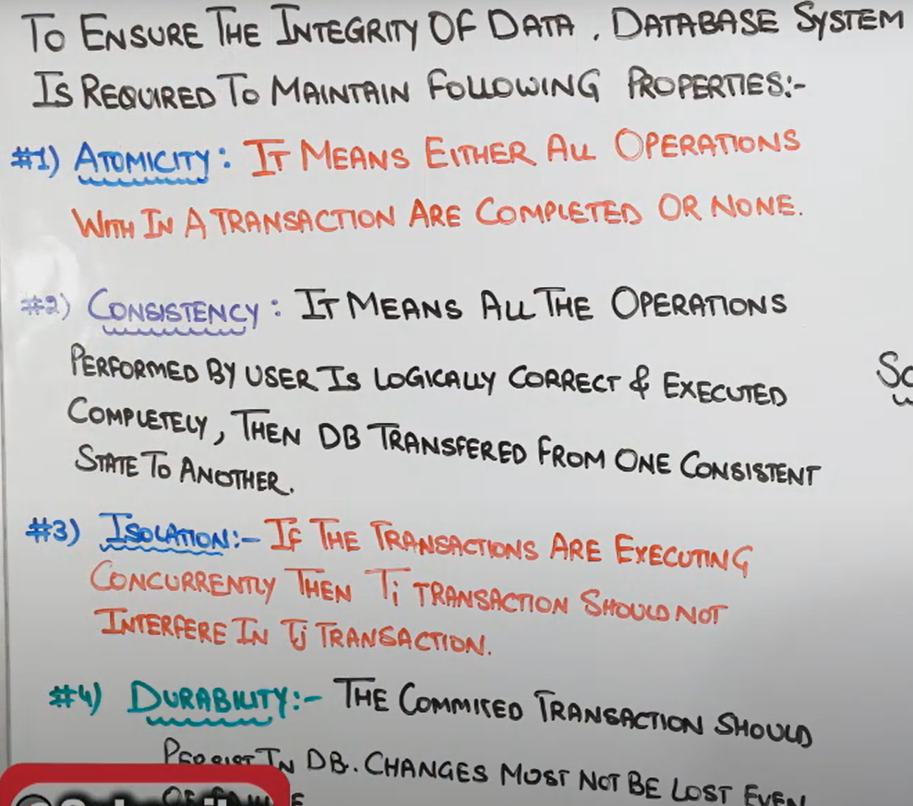

After failure\*

Practical example of each properties:-

1. A for apple no Atomicity

Atomicity means process should be complete entirely or failed entirely.

Eg

Read(A)

A=A-50

Write(A)

--Commit—

Read (B)

A=A+50

Write(B)

Atomicity means there should not be any scenario where 50 rs is debited from account A but did not credited in account B. To avoid such scenario db should follow ATOMICITY rule.

2.C for Consistency

After Atomicity is the process done in logical way that called consistency.

First roll up will be performed than only commit .

No scene where first write is perfomed and then read.

3.I for Isolation

In lamen terms there can be multiple transaction at same time so to avoid the transfer of one transaction in to other .

T1 T2 T3

T1 value should not be replace in t3 and t2 transactions

4.Durablity

It means if there is a scene of db fails then the process should save the staging process.

If there is a transaction from A 🡪B

Read A

A=A-X

Write A

After this ,a problem occur so the process should be saved and no deduction of money should occur. Even after transaction was half done.